Day -5 Assignment
1. Create a table listing 3 types of printers, 2 types of scanners, and 2 types of webcams, and for each, write one real-life use case (for example: 'Inkjet printer – printing college assignments').

Type | Real-Life Use Case
Inkjet Printer | Printing college assignments
Laser Printer | Printing office documents
Thermal Printer | Printing shop receipts
Flatbed Scanner | Scanning certificates and documents
Sheet-fed Scanner | Scanning multiple pages in an office
USB Webcam | Online classes and video calls
Built-in Webcam | Laptop video meetings

2. Draw a labeled diagram showing how a typical home printer connects to a laptop or PC, including the connection interface used (USB, Wi-Fi, or Bluetooth).
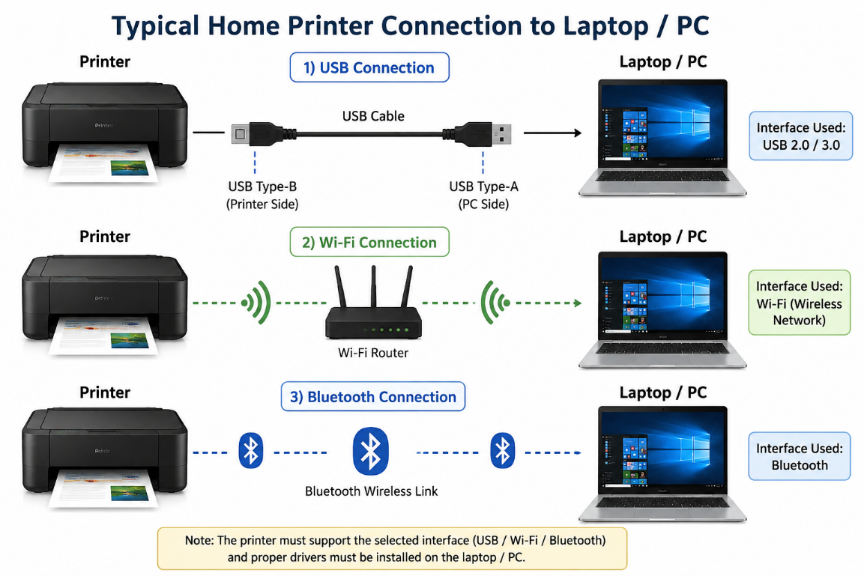

3. List three different connection interfaces (such as USB, Wi-Fi, Bluetooth) used by peripherals like printers, scanners, and webcams, and for each, name one advantage and one disadvantage.<br><br><em><strong>Hint:</strong> Think about speed, convenience, and compatibility.</em>

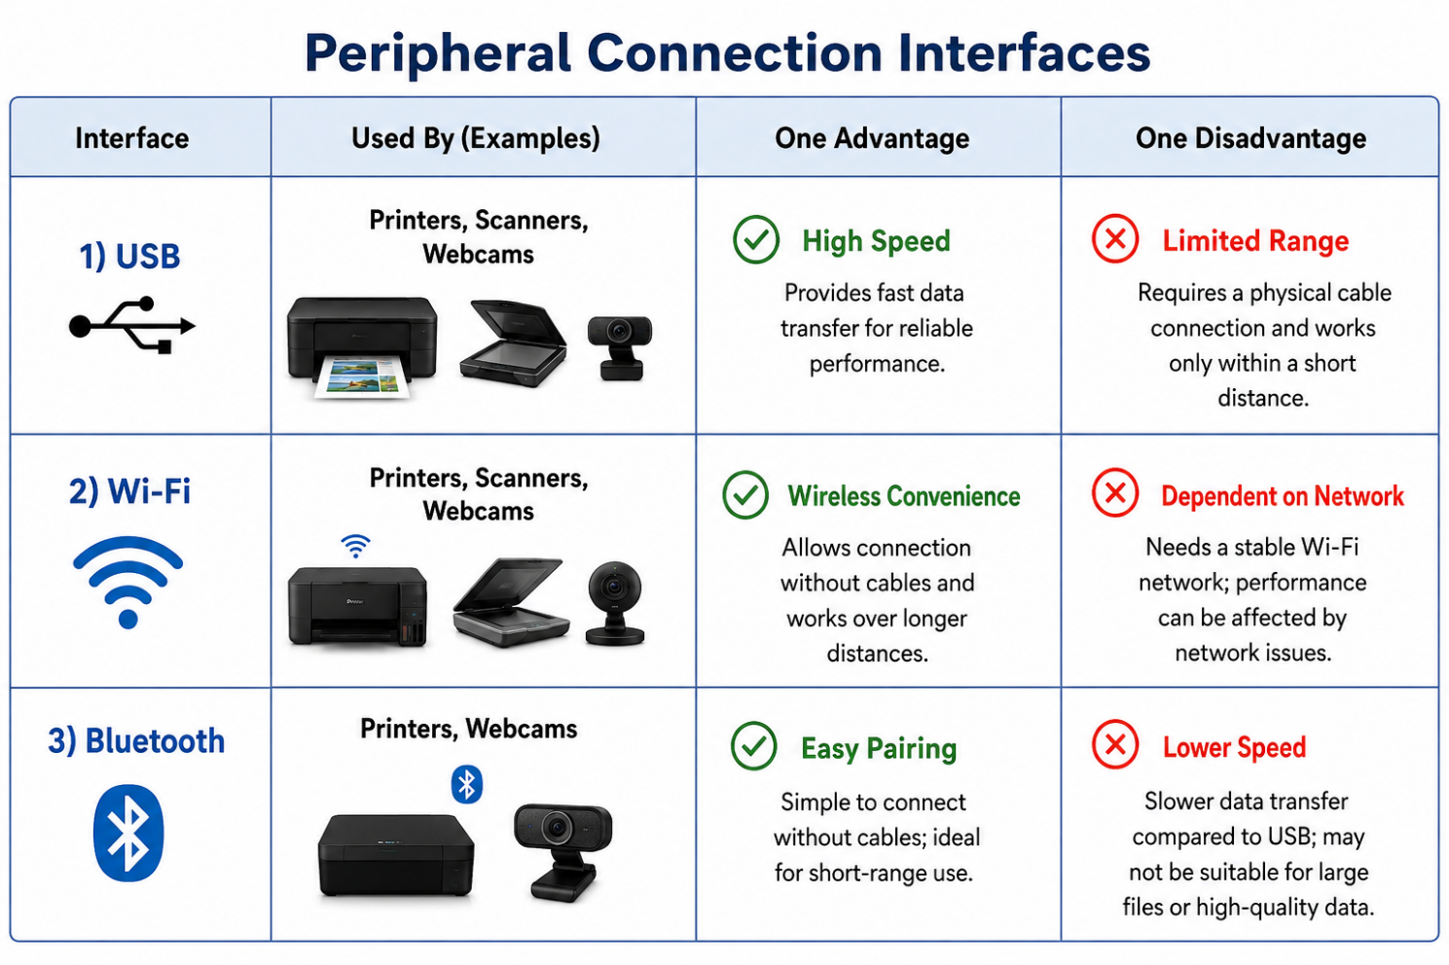

4. Pick any one device you use at home or college (printer, scanner, or webcam). Write step-by-step instructions for how you would connect it to your computer, including what cable or wireless method you would use and any setup steps required.

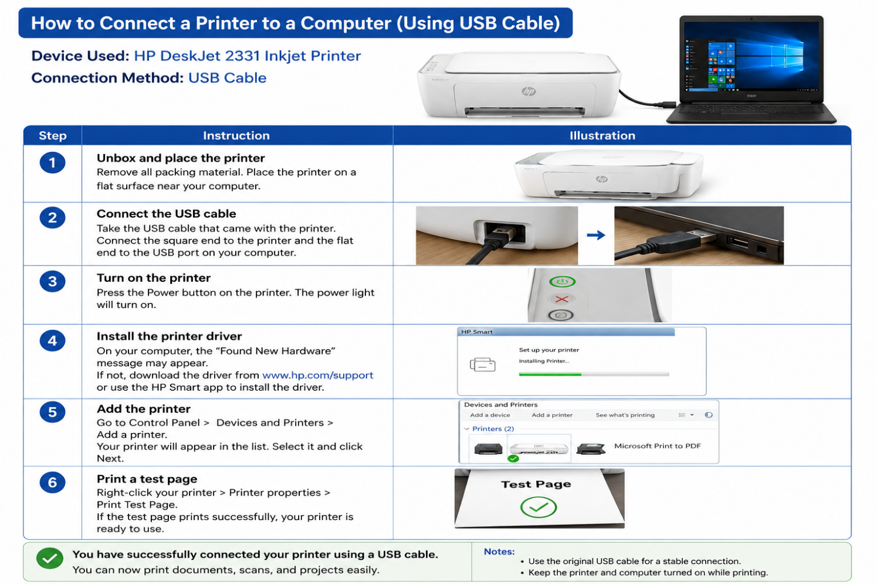

Device: Printer
Connection Method: USB Cable
- Place the Printer – Keep the printer near the computer.
- Connect the USB Cable – Connect the printer's USB port to the computer's USB port.
- Turn On the Printer – Press the power button.
- Install the Driver – Install the required printer driver on the computer.
- Add the Printer – Open Settings → Bluetooth & devices → Printers & scanners → Add device.
- Print a Test Page – Print a test page to confirm that the printer is connected successfully.

